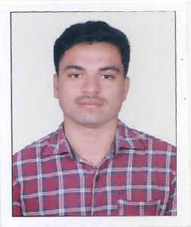
KUNHALI ASHIK G.A
S/o Abbas G
Badriya manzil, Gunaje
Ariyappady (post):671551
Peradala (via)
Kasaragod, Kerala
Mob: +918592917747
E-mail id: ashikgunaje@gmail.com

Summary

A graduate in electronics and communication with strong knowledge of fundamentals of digital logics, computer programming and practices in digital and analog electronic circuits.
Objective

To obtain an entry level position in networking where I can gain experience and knowledge for a potential career in networking engineering.

Education

- B.E in electronics and communication engineering. graduated from P.A college of engineering, Mangalore affiliated to Visvesvaraya Technological University, Belgaum in the year 2015
- Class XII from Gov. Vocational Higher Secondary School, Mulleria in the year 2011
- Class X from Shri Sharadamba High school, Sheni in the year 2009
Training/Certification

- Attended SOFT SKILLS training program from 1st year B.E to 3rd year B.E conducted by F.A.C.E in P.A College of Engineering
- Undergone C workshop conducted by IIT Mumbai and cleared their online test.
- Attended 6 days JOB-PREP placement training program conducted by I-POINT in P.A College of Engineering.
- Completed Cisco Certified Network Associate and Microsoft Certified Server Engineer from Evo Soft Technologies, Kochi.

Technical skills
- Operating Systems: Windows 98, Windows 2000 Server/Professional, Windows xp
Windows 7, Windows 2010 server
Networking

- LAN WAN concepts, routing and switching, configuring inter-vlan communication
- Well versed with Network protocols: TCP/IP and subnetting..
- Configuring routing, Nat, vlan, Access list on routers.
- (Cisco routers 2500 series and switches 2960,3560)
- Familiar with domain concepts and Active directory.
- Configuring ADC,Rodc,DNS.DHCP,FSRM,ISCSI.
- Routing Protocols: RIP, RIP2, EIGRP, and OSPF,

Professional strength

- Good communication and presentation skills.
- Excellent group working.
- Strong analytical ability for problem solving, planning and execution
- Result orientation, ability to get things done under any circumstances
- Ability to get along with people at every level of organizational hierarchy
- Strong enough to work for long time

Personal Details
- Gender : Male
- Marital status : Single
- Nationality : Indian
- Languages Known : English, Kannada. Malayalam
- Hobbies : Listening to music, Watching TV Programmes, News
- Place : Kasaragod

Place: Kasaragod Kunhali Ashik G.A
Date:

